San Diego State University
5500 Campanile Drive
San Diego, CA 92182

Feb 1, 2021

Dear Single Subject Credential Applicant,

Would you benefit from a scholarship of $12,500 to support you during your credential program?

If so, we invite you to apply to become part of the community of SDSU Noyce Scholars in Mathematics Teaching. The goals of this community are to support highly qualified STEM majors into becoming effective mathematics teachers through their participation in SDSU’s single subject credential program and through experiences that continue once teachers begin full-time teaching.

This program provides Noyce Scholars with a scholarship of $12,500 for one year and many opportunities to improve their mathematics teaching practice both during and after the teacher credential program. In exchange for receiving the money, you will be required to teach 2 years of secondary mathematics in a public school in a high-need district in California (for example, San Diego Unified, Grossmont Union, or Sweetwater Union) within several years of your graduating. If this condition is met, the scholarship/loan is “forgiven” and no repayment is required.

On the next few pages you will find instructions and materials needed for applying for the Scholarship. Please be sure to review the entire application and, in particular, the eligibility requirements, in particular, Section C: Eligibility Requirements. Email your completed application to Susan Nickerson, at snickerson@sdsu.edu. Use the Subject Line: Noyce Scholarship Submission

We encourage you to apply no later than March 29, 2021. We will begin reviewing applications then but given continue until scholarships are allotted.

For additional information, please contact Dr. Susan Nickerson (snickerson@sdsu.edu), Dr. Janet Bowers (jbowers@sdsu.edu) or Dr. Randy Philipp (rphilipp@sdsu.edu). We look forward to working with a thoughtful group of prospective teachers.

Sincerely,
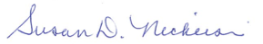 | 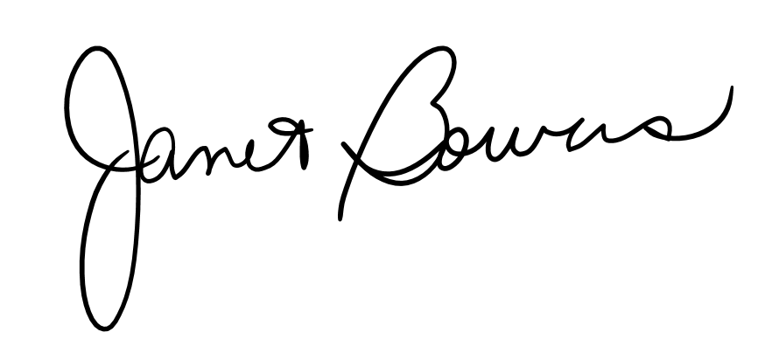 | 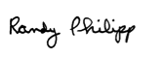
Dr. Nickerson | Dr. Bowers | Dr. Philipp

SDSU Noyce Scholars in Mathematics Teaching: UPTEMPO
Applications must be received by March 29, 2021

Application Checklist

To apply for this program, submit items below:

1. Applicant Information Sheet
2. Confirmation of Eligibility Sheet
3. Essay Response

As the SDSU campus is not currently delivering mail, please email the completed application packet to snickerson@sdsu.edu, as indicated on the first page above.

If you are not able to print and sign and scan (or take a picture) of the signed application, leave the signature field blank (page 4), send in the application by email as instructed, and in the body of the email or in a separate email to snickerson@sdsu.edu, say you understand the items in the table (page 4) and that we have permission to access your SDSU application.

Note that we will also review your SDSU Credential application part of the Scholarship selection process. We will conduct interviews with the most highly qualified applicants.

THANK YOU

Applicant Information Sheet

Name (Last) (First) (MI) ___________________________________________________

SDSU Red ID Number ___________________________________________________

Best Contact Phone Number ________________________________________________

Email Address _______________________________________________________
Undergraduate Major _____________________________________________________

Expected Month/Year of graduation _________________________________________

How did you find out about the Noyce Scholar Program? Please check all that apply.

_____ email
_____ professor
_____ announced in my class
_____ friend
_____ flyer or poster
_____ other: ___________________________________________________________

Confirmation of Eligibility
Noyce Scholars must:
- have graduated with a major in a STEM discipline;
- plan to attend SDSU’s teacher credentialing program if accepted;
- agree to have their application to the SDSU credential program reviewed as part of the Noyce Scholarship Review Process;
- commit to teaching mathematics for at least two years in a public school in a high needs school district;
- commit to responding to surveys and other requests for information, and participate in learning opportunities during the credential program; and
- be a United States citizen, national, or permanent resident alien.

Requirement | Your Response
I graduated or will graduate with a major in a STEM discipline. | Major _______________________________  Year of Graduation ___________
I applied to SDSU’s single-subject or single-subject bilingual mathematics teacher credential program and, if accepted, I plan to attend. | ___ YES I applied to, and if accepted, plan to attend SDSU’s teacher credential program  ___ OTHER. Explain ___________________
I understand that reviewers for this Scholarship will also review my SDSU credential program application as part of the Scholars Review process. | ___ YES I understand they will review my application to the teacher credential program  ___ OTHER. Explain ___________________
I understand that if I am accepted as a Noyce Scholar, I will receive a $12,500 scholarship loan. The $12,500 does not need to be repaid if I teach for at least two years in a school in a local high-need district.* | ___ YES I understand.  ___ OTHER. Explain ___________________
I understand that I will need to respond to surveys and requests for information and participate in learning opportunities during and after the credential program. | ___ YES I understand.  ___ OTHER. Explain ___________________
I am a U.S. citizen, national, or permanent resident alien. | ___ United States citizen  ___ National  ___ Permanent resident alien

My signature below indicates that the information provided in the table is accurate.
Name (Please print) ______________________________________________________
Signature† __________________________________ Date ___________________
* The District should be identified as a high-need district in that at least one of its schools has a high percentage of individuals from families with incomes below the poverty line.
†If you are not able to print and sign and scan (or take a picture) of the signed application, see instructions on page 2.

Essay Response

The commitment associated with this Noyce scholarship is that you will teach mathematics two years in a public high–need school district to be completed within eight years of attaining your credential. In no more than 500 words, describe (a) your interest and enthusiasm for mathematics teaching, and (b) your ability and commitment to working in a high–need school.

